Name:__________________________________________Date:______________
Beastly Tales: Yeti, Bigfoot and the Loch Ness Monster.
Prepared by: Stephen Lauricella and Jorge Zuluaga
Section one: Believe it or not, The Loch Ness Monster (pages. 4 -21)
Vocabulary:
Places: Europe (European), Africa, Indonesia, Scotland (Scottish), Loch Ness, Norway (Norwegian)
Directions: Use a word from the bank to complete the sentences below. Do not repeat words.
remote, tourists, discovery, prehistoric, loch, swirl, mysterious, saint, retreat, swarm, reappear, grainy, murky, fossil, flipper, enthusiast,

- Dinosaurs lived during the ____________________________ times.
- There was a _______________________ of bees around the honey.
- China is so far away that we say that it is a _______________ Place.
- Animals such as penguins, seals, or whales use this for swimming: ________________________
- There were a lot of _______________________ in Disney World!
- Finding something new is a ____________________________
- A _______________________ is a lake.
- Someone who is an _____________________ knows and likes something a lot.
- The scientists tried to look at a picture, but it was too ___________________ that they could not see what they wanted.
- To turn around and around ___________________________
- A strange, unknown, and __________________ fish lives in the sea
- The water from the lake was too __________________ that we could not see the bottom.
- ________________ are very old remains of animals or plants.
- The soldiers had to ________________ so they can stay safe.
- A very good person is called a ______________________.

Name:__________________________________________Date:______________
- What is the author’s purposes for writing this selection
http://www.fcatexplorer.com/media/parent/tiplister/flash/tip210a.swf
- To inform and persuade
- To entertain and inform
- To persuade and entertain
- What is the genre of the selection
- Science fiction
- Mystery
- Fantasy
- Nonfiction
- Fiction
- Name three creatures that really exist, but people thought they were made up by storytellers?
- _____________________________________________
- _____________________________________________
- ______________________________________________

- What did Jim Ayton see in 1963?
- A komodo dragon
- A giant squid
- A horse swimming in the loch
- An enormous creature moving silently down the lake
- Who else saw the creature that day?
- Jim’s father and mother
- Jim’s father and two other men
- A group of fishermen
- Anthony Shields

- Why did Jim and his father think that nobody would believe what they had seen? _______________________________________________________________________________________________________________________________________________________________________________________________________________________
- When did The Loch Ness monster become famous?
- In 1963
- In 1,400
- In 565 AD
- In 1933
- What happened after a road was built around the sides of the Loch Ness Valley?
- Tourists could not explore the area
- Saint Columba ordered the monster to leave
- People started to visit the Loch Ness Area
- After a road was built around the steep sides of the Loch Ness valley, tourists could now explore this remote area for the first time. Do you think all of the Loch Ness monster sightings were true? If not, why would someone lie about the sighting?
________________________________________________________________________________________________________________________________________________________________________________________________________________________
- Based on the passage, which of the following statements is not true
- Newspapers paid a lot of money for any picture of the monster
- A lot of people went to the loch
- Scientists brought special equipment to get better images
- The sonar scanners showed a perfect image of the Loch Ness monster

- According to the passage, the following sentences are true about the Cryptocleidus, except:
- The Criptocleidus was an enormous reptile that lived in the sea.
- The Criptocleidus existed more that 70 million years ago.
- Scientists are sure that the Loch Ness monster was a Criptocleidus that survived unnoticed.
- The Criptocleidus was a kind of dinosaur.

- According to the map on page 6, Loch Ness is located in which country?
- Northern Ireland
- Republic of Ireland
- England
- Scotland
- In detail, describe the location of Loch Ness.
________________________________________________________________________________________________________________________________________________________________________________________________________________________________________________

- A simile is when you compare two things using the words like or as. The author uses similes to compare the Loch Ness monster. Write the two similes the author uses to compare the Loch Ness monster. (Page 8)
- ___________________________________________________________________________________________________________________________________________________________________________
- ___________________________________________________________________________________________________________________________________________________________________________________

- On page 21 why does Cryptocleidus (krip - toe - KLIE - duss) have these letters in parenthesis?
- to show the correct spelling of the word
- to give the definition
- to explain how to read the word
- to call attention to an important word

- In your opinion, do you think the Loch Ness Monster really existed? Use evidence from the text to support your answer. Your paragraph should be at least 5 complete sentences. When you are finished check over your work for correct capitalization and punctuation.
- __________________________________________________________________________________________________________________
B.__________________________________________________________ ____________________________________________________________
C.______________________________________________________________________________________________________________________
D.__________________________________________________________________________________________________________________________________________________________________________________
E.______________________________________________________________________________________________________________________

Name:__________________________________________ Date: _____________
Beastly Tales: Yeti, Bigfoot and the Loch Ness Monster.
Prepared by: Stephen Lauricella and Jorge Zuluaga
Section two: Yeti, Big foot (pages. 22 -35)
Places: Nepal (Nepalese), Mount Everest, Himalayas, Tibet
Vocabulary: Match a word from the left with a definition from the right
Monastery  eyewitness  Evidence  Yak  yeti  grunt  scalp  Sherpa  investigate  abominable  Mountaineers | - Somebody who lives in a mountainous area.  - A large longhaired ox that has long curved horns.  - Somebody who saw and can give evidence about an event  - look into, explore  - A building in which a group of people, especially monks, live together  - The skin and underlying tissues covering the dome of the skull  - Noise that a pig makes or a vocal sound that resembles it.  - Something that gives a sign or proof of the existence or truth of something  - Extremely repugnant or offensive  - The skin and underlying tissues covering the dome of the skull  - People originally from Tibet who live on the southern slopes of the Himalayan range
Name:_________________________________________ Date: ______________
Directions: Read the passage “Yeti” (pages 22 to 27) and choose the best answer from the choices given.
- Where did Lhakpa live?
- India
- Nepal
- A Buddhist monastery
- Why did she climb up Mount Everest every day?
- To exercise herself
- To pick up some berries
- to watch at the mountain tops
- to graze her herd of yaks
- Who lives up in the mountain?
- Indians
- Nepalese people
- Buddhist monks
- What is the highest mountain in the world?
- The Appalachian mountains
- Grandfather mountain
- Mount Everest
- Why did not Lhakpa expect to see the yeti?
- Because she was blind
- Because the mountains stretched for thousands of miles
- Why are yaks valuable for the people who live in the Himalayas?
- They use them for food, clothing and fuel
- They ride them in competitions
- They show the way, if somebody is lost
- What did Lhakpa do when she saw the yeti?
- She called her mother
- She ran away
- She rushed toward him.
- She froze
- What did the yeti do to her?
- He told her a story about the Monks
- He whirled and danced with her
- He grabbed her and dropped her into an ice stream
- He protected her with his long hairy arms
- What did the yeti do to the yaks?
- He clipped their hairs
- He killed all of them
- He killed three of them
- What did the police find?
- They found Lhakpa’s boots
- They found the yeti
- They found the yeti’s footprints
- They found a new way to climb the Himalayas
Name:_________________________________________ Date: ______________
Directions: Read the passage “Yeti” (pages 28 to 35) and answer the questions with information from the selection
1. Yaks are valuable creatures for people who live in the Himalayas. These hardy beasts provide what four things?

A. _____________________________________________________

B. _____________________________________________________

C. ____________________________________________________
D._____________________________________________________

2. Why would Erick Shipton place an ax near the footprint of the Yeti?

- To compare the shape of the footprint with the ax

- To show the approximate size of the footprint

- To show how much it has snowed that day

- to show how much snow has melted

3. True or False. A Yeti’s footprint is three times as wide as a human footprint.

___________________________________________

4. What does the author find the most amazing about the clear toe prints?

- How long the toes are

- How long the foot is

- How wide the foot is

- he creature was walking in the snow barefoot

5. Where does the name “yeti” come from?

____________________________________________________________________
6. What does “yeti” mean?

7. What is another name for the yeti?

- Abominable Snowman

- Bigfoot

- Loch Ness

- Cryptocleidus

8. True or False. The yeti scalp given to Sir Edmund Hillary turned out to be a fake made of goat - antelope hair.

__________________________________________________________

Name:_________________________________________ Date: ______________
Directions: Cut out each of the definitions and glue them next to the correct vocabulary word from the passage “Bigfoot”
Bigfoot |  | Bottom of shoe or foot
Suit |  | A person who gathers trees for wood
Captors |  | Equipped with one or more weapons
Century |  | Without doubt
Armed |  | A mixture that is applied as a liquid paste and dries to a hard surface. usually used to make copies of objects
Logger |  | A huge haired beast that looks half ape and half human.
Plaster |  | A large brownish rodent of the squirrel family that lives on the ground and in burrows.
Sole |  | A person or animal that takes or holds another person or animal prisoner
Marmot |  | 100 years
Absolute |  | Outfit, costume

Name: _______________________________________Date: ________________
Directions: Read the passage “Big Foot” (pages 36 to 47) and choose the best answer from the choices given.
Places or locations you will find in the reading:
Vancouver, Canada, Pacific Northwest, California, U.S.A. Russia, Oregon, Washington
- What did Albert Ostman do in 1924?
- He visited the Himalayas
- He spotted a yeti while he was camping
- He went on a camping trip to Vancouver

- What was searching through his pack?
- A yeti
- A porcupine
- A bear
- A bigfoot
- Why do you think the author placed a map on page 36?
- To show a good place for camping
- To show the place where bigfoot lives
- To Show where the United States is

- Where is the mysterious bigfoot said to live?
- In the Himalayas
- In the Pacific Nortwest
- In Vancouver
- None of the above
- What carried Albert over rough ground?
- A mountaineer
- A monk
- A bigfoot
- All of the above
- When did Albert escape?
- Albert hit a bigfoot on his scalp and ran away
- Albert used his camera to scare the family of bigfoots
- When a bigfoot ate tobacco, he got sick and Albert escaped
- When daylight came, Albert ran away

- How long was Albert kept captive?
- For a month
- For a day
- For six days
- For an hour

- What is the difference between a bigfoot and a yeti?
- There is not a difference. They are the same
- The bigfoot is bigger than the yeti
- The yeti has more hair than the bigfoot
- Nobody has ever seen a yeti
- About how big is the foot of a bigfoot?
- About 12 centimeters
- About 12 inches
- About 15 inches
- About 15 Centimeters

- Why did the author use the words “Armed with a movie camera” on page 42
- To show that cameras are good weapons
- To show that Roger Patterson planned to film a bigfoot
- To Show that cameras are not weapons
- none of the above

- How did Roger Patterson and his friend go to the area where they spotted bigfoot?
- They took a train for three days
- They rode their horses
- They walked and took a boat
- none of the above
- Why is it hard to prove that Patterson’s film is fake?
- Because Patterson made plaster casts of bigfoot’s footprints
- Because it is hard for people to run in a bigfoot costume
- Because everybody knows that bigfoot does not exist
- All of the above
- What did the bigfoot from Oregon State do to the marmots?
- He hit the marmots with a rock
- He ate the marmots one by one
- He helped the marmots escape from the hunters
- He helped the marmots to build a new nest
1. What is the difference between bigfoot’s footprints and a human footprints.

A. Bigfoot has 6 toes and a human footprint has 5 toes

B. There are no differences between the two.

C. Bigfoot has a much flatter sole than a human foot

D. A human foot has a much flatter sole than bigfoot

2. What four things has bigfoot been spotted eating?

A. _______________________________________________________

B. _______________________________________________________
C. _______________________________________________________

D. _______________________________________________________

3. What other names did Native Americans give for bigfoot?

A. Sasquatch

B. Oh - mah - ah

C. Sasquatch and Shipton

D. Sasquatch and Oh - mah - ah

4. Use the Venn Diagram to Compare and Contrast yeti to bigfoot.
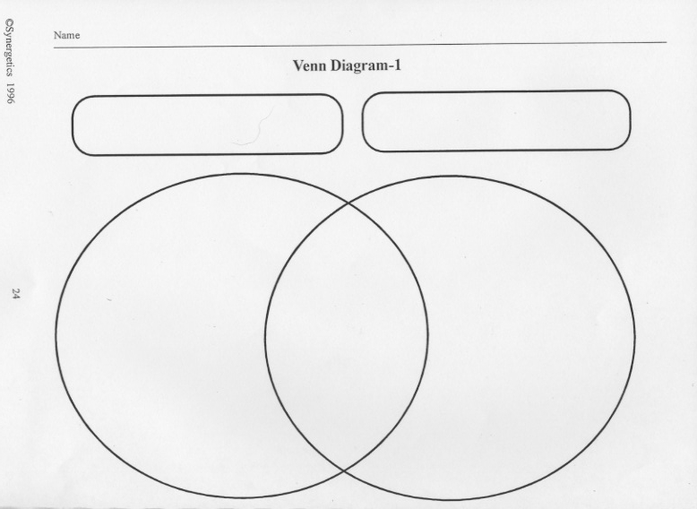
5. Tape recordings show different ways bigfeet may communicate. What are the different sounds that were recorded?

- _________________________________________________________

- _________________________________________________________

- ___ _____________________________________________________
- ________________________________________________________
6. You and your friend are going camping to try and catch bigfoot. As the two of you are walking you happen to see a frequently used trail by bigfoot. Write 5 - 7 complete sentences on how you would try to capture bigfoot. Be sure to tell us if you were able to capture bigfoot. Use your imagination!!!! When you are finished, draw a picture of what you wrote.

A. ____________________________________________________
B. ______________________________________________________
C. _______________________________________________________
D. _______________________________________________________
E. _______________________________________________________

