STUART LITTLE
By: E.B. White
Discussion and Activity Guide

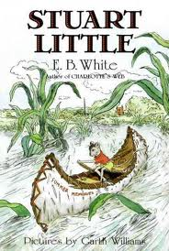
Chapter One-- In the Drain
1. Describe the appearance of Stuart when he first arrived.
__________________________________________________________________________________________________________________________________________________________________________________________________________________________________________
2. What is the family’s initial reaction to Stuart?
a. angry
b. surprised
c. disappointed
d. scared

3. How do you think you would feel if you were in Mr. and Mrs. Little’s position?
______________________________________________________________________________
______________________________________________________________________________
______________________________________________________________________________

3. What building materials were used to construct (build) Stuart's bed?
a. a dresser drawer
b. a match box
c. four clothes pins and a cigarette box
d. a shoe box

4. What could Stuart Little do from the moment he was born?
a. walk
b. climb lamps
c. sing
d. talk
5. Describe some of the ways in which Mrs. Little handled the challenge of Stuart being so small. ______________________________________________________________________________
______________________________________________________________________________
______________________________________________________________________________
______________________________________________________________________________

6. Why do you think chapter one is titled “In The Drain”?
a. Stuart fell into a drain.
b. Stuart had to go into the drain to get his mother’s ring.
c. He lived in the drain
d. He was afraid of the drain
Vocabulary: manner, shinny, preferred, solemnly, inquired, trifle, annoyed, slimy

Chapter Two – Home Problems
1. In what way did Stuart help when his family played ping pong?
a. He held up the net.
b. He kept the balls from falling off the ping pong table.
c. He was able to run under furniture and the radiator to get the balls.
d. He cleaned the paddles.

2. Why did the Little’s tear “Three Blind Mice” from the nursery songbook?
a. They did not want him to be afraid that his tail was going to be cut off by a farmer’s wife.
b. They did not want him to be afraid of mice.
c. They did not want him to run through the house like the mice in the story.
d. They did not want him to know he was a mouse.

3. How did Stuart help with the problem with the piano keys?
a. He climbed inside and nailed the loose boards in place.
b. He pushed the sticky key up when it was played.
c. He would sing along with the song being played.
d. He would take a nap.

4. What was Mr. Little most worried about?
a. Stuart running away.
b. The mouse hole
c. Stuart playing the piano
d. Stuart losing his hearing
5. What was the main idea of chapter two?
______________________________________________________________________________
______________________________________________________________________________
Vocabulary: radiators, perspiration, session, emerge, references, belittling, louse, grouse, souse, pantry, venture

Chapter Three – Washing Up
1. What was Stuart’s morning routine like?
a. He would get up, take a bath, and eat breakfast.
b. He would get up, wake, his family, and go out to play.
c. He would get up, exercised, and go wash up.
d. He would get up, wake the cat, and play the piano.

2. Why did Stuart have to figure out how to do a lot of things by himself?
______________________________________________________________________________
______________________________________________________________________________
______________________________________________________________________________

3. How did Stuart get to the washbasin in the bathroom?
a. He climbed up the pipes.
b. George picked him up put him up there.
c. He swung across on the string he used for turning on the light.
d. He climbed a rope ladder.

4. What make the plink, plink, plink when Stuart was in the bathroom?
a. The wooden hammer his father made for turning on the water
b. Stuart’s toothbrush
c. The cat
d. The water dripping on floor

5. What is chapter 3 mostly about?
______________________________________________________________________________
______________________________________________________________________________
______________________________________________________________________________
______________________________________________________________________________
Vocabulary: pale, abdominal, friar, abbey, brace, awl, faucet

Chapter Four – Exercise
1. How do you think Snowbell felt about Stuart?
______________________________________________________________________________
______________________________________________________________________________
______________________________________________________________________________
2. Why did Snowbell show Stuart his teeth?
a. He was going to eat him.
b. He wanted to scare him.
c. He was showing Stuart that his teeth were bigger.
d. He has a loose tooth

3. What caused Stuart to get wrapped up inside the window shade?
a. Snowbell rolled him up in it.
b. He jumped onto the shade ring too hard causing the shade to roll up with him in it.
c. He was trying to clean the windows.
d. He was looking out the window to see if it was raining.

4. Why do you think Snowbell placed Stuart's hat and cane by the entrance to the mousehole?
______________________________________________________________________________
______________________________________________________________________________
______________________________________________________________________________
Vocabulary: custom, gleaming, trapeze, sill, acrobats, fond, shrill

Chapter Five – Rescued
1. How did George plan to rescue Stuart?
a. He wanted to rip up the pantry floor.
b. He was going to tear down the wall around the mouse hole.
c. He wanted to put some cheese in the entrance to the hole to make him come out.
d. He wanted to play Stuart’s favorite song
2. What did George intend to do with the applesauce?
______________________________________________________________________________
______________________________________________________________________________
______________________________________________________________________________

3. What did Mr. Little insist that they do first?
______________________________________________________________________________

4. Why did the Bureau of Missing Persons hang up in disgust?
a. They were too busy
b. It was too cold for them to form a search party
c. There was too much background noise for them to hear what Mr. Little was saying
d. because Mr. Little told them Stuart was only two inches tall
5. What did George find in the cellar?
a. an old ball
b. another entrance to the mouse hole
c. an old rowing machine
d. a family of mice
6. Why did George say they should pull down all the shades?
a. he wanted to take a nap
b. to show respect for the dead
c. So no one would see them all crying
d. He was looking for Stuart
Vocabulary: ice pick, vigorous, pry, wedged, bellowed, cramped, disgust, discarded, sorrow, exasperated, cope

Chapter Six – A Fair Breeze
1. Describe what Stuart would do whenever he saw a dog through his spyglass.
______________________________________________________________________________
______________________________________________________________________________
______________________________________________________________________________
______________________________________________________________________________

2. How did the owner of the Wasp react when Stuart stated that he would defeat the sloop by cracking on more sail?
______________________________________________________________________________
______________________________________________________________________________
______________________________________________________________________________
3. Why did Stuart grab hold of the cuff of a gentleman's pants?
a. He wanted to hide from the people on the bus.
b. He wanted to go with the gentleman to work.
c. The bus step was too high for him to get on
d. He was trying to get away from a cat

4. Why did the owner of the Wasp detest the Lillian B. Womrath?
a. because the Womrath always beat the Wasp
b. because the Womrath was always bumping into the Wasp and the owner did not
understand sailing

c. It was a better looking boat.

d. The Womrath was a bigger boat.

5. How did the owner of the Wasp react when Stuart stated that he would defeat the sloop by cracking on more sail?
______________________________________________________________________________
______________________________________________________________________________
______________________________________________________________________________

Vocabulary: spyglass, sauntered, trousers, fare, conductor, tartly, sloop, schooner, enormous, clipper, sober, crisply, diminutive, loyally, squall, squid, detestable, capsizing, disabled, yawing

Chapter seven – The Sailboat Race
1. Why were all the people pushing to get a better view of the pond?
a. They heard one of the sailboats was being steered by a mouse.

b. They wanted to see who would win.

c. Two of the boats had crashed into one another.

d. There was a giant fish in the pond.

2. In what city can you find Central Park?
a. North Carolina

b. California

c. New York

d. Virginia

3. How does LeRoy try to get Stuart to steer his boat.
______________________________________________________________________________

______________________________________________________________________________

4. Describe the accident that happened on shore shortly after the boats had set sail?
______________________________________________________________________________
______________________________________________________________________________
______________________________________________________________________________

5. Why was Stuart alarmed when he noticed that the barometer had fallen.

a. He had gotten wet and did not want to freeze.

b. It meant bad weather was coming.

c. It was about to snow.

d. It was getting foggy and they could not see.

6. What obstacle did Stuart spot that lay dead ahead?
a. an enormous paper bag

b. a log

c. a rock sticking out of the water

d. a cave

7. Which ship crossed the finish line first?
______________________________________________________________
8. Why did the policeman refuse to shake hands with Stuart?

a. He was afraid of him.

b. He was too wet and mad.

c. He thought Stuart had pushed him.

d. He was in a hurry and did not have time.

Vocabulary: sulky, serge, fragments, consternation, barometer, ominous, looming, halyards, vessel, helm

Chapter Eight – Margalo

1. Why was Stuart so hard to find around the house?

a. He liked to hide.

b. He was so small.

c. He often got lost.

d. He liked to read in dark corners.

2. Where did Stuart find himself stuck for half an hour?

a. in the refrigerator

b. In the cabinet

c. in the box of pudding mix

d. in a kitchen drawer

3. Why did Stuart have to stay in his bed for two weeks?
______________________________________________________________________________

______________________________________________________________________________

4. Who was the new visitor in the Little home?

a. another mouse

b. a kitten

c. a bird

d. a new baby

5. Why did Snowbell run off toward the kitchen squealing in pain?

a. His foot got caught in a trap.

b. Stuart shot him in the ear with his bow and arrow.

c. A book from the shelf fell on his head.

d. Stuart bit him.

Vocabulary: penetrated, stumbled, nip, broth, bronchitis

Chapter Nine – A Narrow Escape

1. When Stuart recovered from bronchitis, what does he do? (p.57)
______________________________________________________________________________

______________________________________________________________________________

2. Why does Stuart get into a garbage truck? (p.58)
______________________________________________________________________________

______________________________________________________________________________

3. Describe Stuart’s awful situation when he is in the messy
garbage pile. (p.59)
______________________________________________________________________________

______________________________________________________________________________

4. Who finds Stuart in the garbage scow? (p.61)
______________________________________________________________________________

______________________________________________________________________________

5. How do they return home? (p.63) 1 / 1
______________________________________________________________________________

______________________________________________________________________________

Vocabulary: fast, grove, hoisted, pier, scow, modestly, gingerly, gloomily, inquired, buoys

Chapter 10 – Springtime

1. Who were Snowbell’s friends and how many were there? (p. 67)
______________________________________________________________________________

______________________________________________________________________________

2. Why were two possible reasons that Snowbell liked daytime better than nighttime? (p. 67)
______________________________________________________________________________

______________________________________________________________________________

______________________________________________________________________________

3. How did snowbell use the vine at the Little’s house? (p. 68)
______________________________________________________________________________

______________________________________________________________________________

4. What happened to mess up the Angora cat’s plan? (p.71)
______________________________________________________________________________

______________________________________________________________________________

______________________________________________________________________________

5. What was Margalo’s reaction to the news? (p.71)
______________________________________________________________________________

______________________________________________________________________________

______________________________________________________________________________

Chapter Eleven - The Automobile

1. Why was Stuart so upset when George said that Margalo may have a husband somewhere?
______________________________________________________________________________

______________________________________________________________________________

2. Why did Stuart decide to leave home?
a. to seek his fortune

b. He was getting married.

c. He was going to the beach.

d. He was going to look for Margalo

3. What did Stuart use the handkerchief for?
a. to wipe his eyes because he was crying.

b. to carry his belongings

c. to roll up in his bed so no one would know he was gone.

d. He used it as a belt.

4. Why do you think Stuart took a strand of hair from Mrs. Little's comb?
______________________________________________________________________________

5. What did Dr. Carey tell Stuart that he needed for his journey?
a. a car

b. a hot air balloon

c. a bicycle

d. a ship

6. Explain what happened when Stuart pushed the special little button on the car's instrument panel.
______________________________________________________________________________

7. What happened when Stuart tried to push the special button again?
______________________________________________________________________________

______________________________________________________________________________

Vocabulary: coop, irritably, heartbroken, strand, jauntily, slung, pincer, fenders, extracting, hearth, punctured

Chapter twelve – The Schoolroom

1. Why did Stuart start his trip early the next morning?
a. to avoid traffic

b. He wanted to stop and get breakfast

c. He wanted to go by home to say goodbye

d. He wanted to see the sunrise.

2. Who did Stuart see seated deep in thought by the side of the road and what was he worried about?
____________________________________________________________________________

____________________________________________________________________________

3. How was Stuart able to help?
a. He said he would find someone to take the teacher’s place.

b. He said he would be the substitute teacher.

c. He told the superintendent to close school for a while.

d. He told him to put all the kids in another class.

4. What explanation did Stuart give for Miss Gunderson's absence?
a. She had an upset stomach.

b. She was having surgery.

c. She had vitamin trouble.

d. She broke her leg.

5. Why do you think Stuart decided to ignore the regular subjects that day.
______________________________________________________________________________

______________________________________________________________________________

______________________________________________________________________________

Vocabulary: accessories, togs, scholars, briskly, stalked, nimbly, glared, lapel, abomination, vice, temperament, nix, timidly

Chapter Thirteen – Ames’ Crossing
1. Describe the town where Stuart stops that afternoon.
______________________________________________________________________________
______________________________________________________________________________
______________________________________________________________________________
_____________________________________________________________________________________

2. Why did Stuart stop in Ame's Crossing?
a. to have lunch

b. to get a drink of sarsaparilla

c. to get some gas

d. to take a nap

3. Who does the storekeeper suggest that Stuart should meet?
______________________________________________________________________________
4. Name two things that let you know that the Ameses have plenty of money?
______________________________________________________________________________
______________________________________________________________________________

5. Summarize the letter Stuart wrote to Harriet.
______________________________________________________________________________
______________________________________________________________________________
______________________________________________________________________________
______________________________________________________________________________
6. What did Stuart forget in all the excitement?
a. that he did not have a canoe
b. that he was afraid of the water
c. that he gets motion sick
d. that he does not like to be outside
Vocabulary: sarsaparilla, ruinous, thistles, prominent, ancestors, lingered, stamen, correspondence, confidential, petty, tranquil, lashed, thwarts

Chapter fourteen – An Evening on the River
1. How had Stuart been swindled?
______________________________________________________________________________
2. Why did Stuart climb the spruce tree?
a. to get away from a dog
b. to get spruce gum to patch the holes in the canoe
c. to take a nap before his trip
d. to look for Margalo
3. Why did Stuart carry the stones to the water’s edge?
a. to make a bridge across the water
b. to cover the holes in the canoe
c. to make a barbecue pit to cook on
d. to stabilize the boat
4. Why did Stuart have to keep changing his shirts?
______________________________________________________________________________
______________________________________________________________________________
Explain what happened to the canoe.
______________________________________________________________________________
______________________________________________________________________________
Vocabulary: stern, swindled, bailed, cranky, ballast, seams, morrow, episode, whippoorwill, errand, perspiration, fidgeting, sulk

Chapter fifteen – Heading North
1. Where did Stuart sleep that night?
______________________________________________________________________________
______________________________________________________________________________
2. What did the filling station man use to fill the car's gas tank?
______________________________________________________________________________
3. How did Stuart know that the man leaning against the signpost must be a repairman for the telephone company?
______________________________________________________________________________
______________________________________________________________________________
4. Why did Stuart give the repairman his card?
a. He wanted to have a phone installed.
b. so he could call if he saw Margalo
c. So they could get together for dinner
d. So he could give Stuart directions as he drove around
Vocabulary: attendant, bosom, vale, junipers, junctions, peered

STUART LITTLE SEQUENCING
Number the events below in the order they happened in the story.

___ Stuart rides the Wasp across the pond

___ Stuart Little, a mouse, is born to a family of humans.

___ Stuart gets caught in the shade.

___ Stuart uses a hammer to turn on the water.

___ Stuart helps with lost ping-pong balls and stuck piano keys.

___ The Littles think Stuart is in the mouse hole.

___ Stuart helps get the ring from the drain.
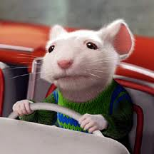 As students begin to read the book, fill in the chart with examples of real and make believe events from the story. Discuss why the events could or could not happen.
Realism and Fantasy

Realism | Fantasy
Vocabulary 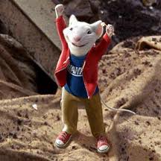
Add words from the chapter under the correct column, find the page number where the word is located, and use context clues to help you determine the meaning.
To the teacher: You can add words prior to giving this page to your students, or you can have students add words as you read the novel.

Word | Page # | Meaning/Definition
SETTING

The story Stuart Little takes place in several different setting. Look back in the story and find two important details about each place listed below.

The Little’s Home
1.___________________________________________________

2.___________________________________________________

At the pond
1.___________________________________________________

2. __________________________________________________

In the School
1.___________________________________________________

2. __________________________________________________

Ames’ Crossing
1.___________________________________________________

2. __________________________________________________
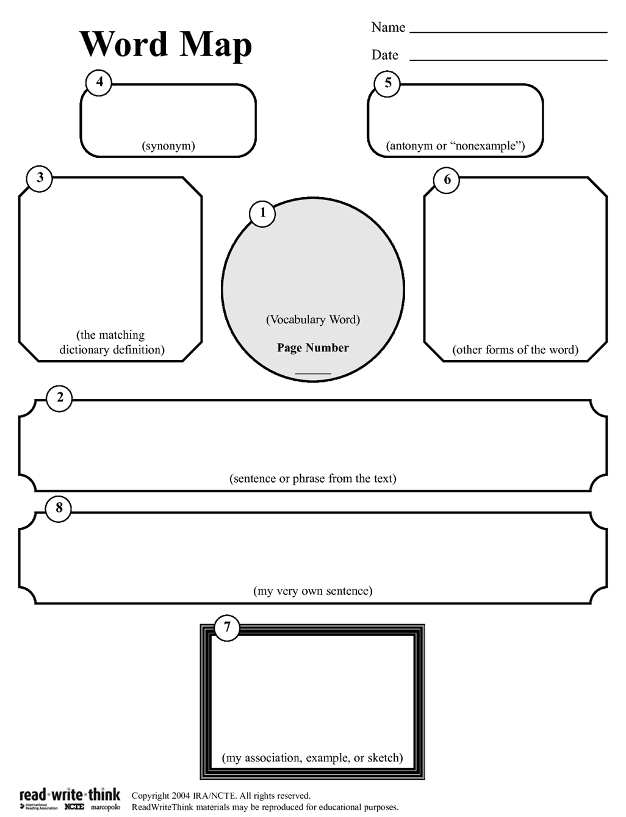Use the chart below to identify different occurrences of conflict in the story.

